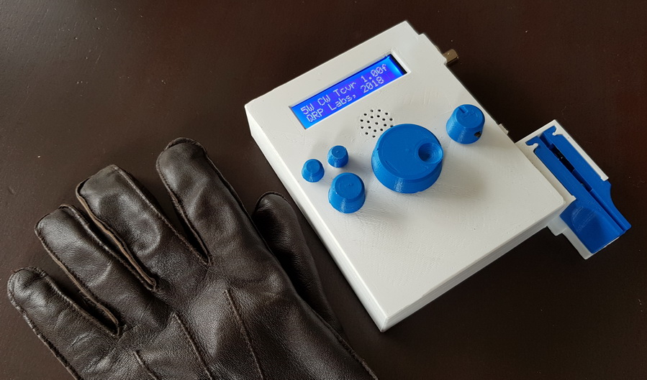

A compact 3D printed enclosure for the QCX transceiver, with integrated paddles

*Torbjorn Skauli, LA4ZCA (tskauli@gmail.com)*

## Description

This note describes a design for a 3D printed enclosure for the [QCX transceiver kit](https://www.qrp-labs.com/qcx.html) from [QRP labs](https://www.qrp-labs.com/). The goal for the design has been to make a small and self-contained unit, to make it easy to bring the transceiver along for portable operation. Therefore, many features are built in:

* paddles which can be flipped to a parking position for storage
* speaker, in addition to an earphone connector
* LiPo 4s battery, giving a transmit power of 5W
* GPS for WSPR operation, enabled or disabled by the power switch

If you want to reproduce the design from the provided documentation here, be warned that it is not entirely straightforward. There is a fair amount of wiring in addition to the 3D printing, and assembly is tight. You may have to adapt the 3D design to fit the parts available to you, or adjust the design according to the particulars of your 3D printer. For that, OpenSCAD source code is provided for the printed parts.

## Parts

[OpenSCAD](https://www.openscad.org/) source and STL 3D files are provided for the enclosure, lid, paddles, and buttons. The enclosure imports parts via an intermediate include file QCXcabinetPaddleAttach.scad from a copy of the separate paddle design. Note that some of the provided source files are nearly identical, with different parameter settings to produce different parts. The other parts needed, in addition to the QCX kit itself, are:

* speaker amplifier module based on PAM8403
* GPS module such as V.KEL VK2828U7G5LF
* 2 silicon diodes, 1N4148 or equivalent
* speaker, 28x40 mm
* earphone jack for hole mounting
* resistor 15 ohm
* electrolytic capacitor 100 uF, 6 volts
* ferrite beads, multi-hole
* optionally a 1A resettable polyfuse
* hardware for the paddles, as described in the text

The parts are readily available from various online stores.

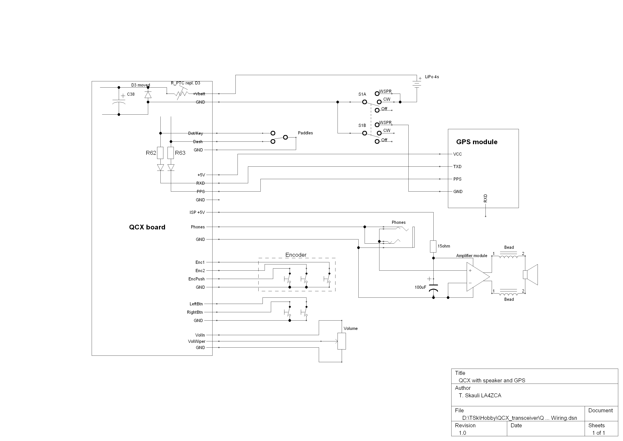

*Figure 1. Wiring diagram. See text.*

## Electrical

The wiring is shown in Figure 1. A 3-way 2-pole rotary switch connects power to the QCX, and also to the GPS when set in the WSPR position. The switch is in the ground lead so that when the GPS is off, it cannot pull the paddle lines low. Two diodes added in series with R62 and R63 ensure that the GPS is not affected by, or affecting, paddle signals when off.

A resettable polyfuse is mounted in the place of D3 to tame the potentially destructive current from the LiPo battery, also eliminating the diode voltage drop. For good measure, the diode is reused as a reverse polarity protection, by connecting it in the reverse direction across C38.

To make a GPS module work with the QCX, it turned out to be necessary to disable the "GLL" NMEA message. This requires the GPS module to be temporarily connected to a computer for reconfiguration, typically via a USB to serial adapter with TTL levels. I used the U-Blox [U-Center](https://www.u-blox.com/en/product/u-center) software to do the reconfiguration. The V.KEL GPS unit turns out to be a favourable choice because it retains its settings indefinitely, while some other models depend on a small battery or supercap that eventually discharges, leading to a factory reset.

The speaker amplifier module used in my build is based on the PAM8403 class D amplifier (using only one of the stereo channels). The amplifier requires 5 volts, which is supplied from the unused ISP header, close to the regulator. There is an obvious risk of spurs and feedback from the amplifier. I was able to suppress such effects using the decoupling and filtering scheme shown, with an RC filter in the +5V supply and ferrite beads on the speaker wires. The beads are of a type with multiple holes, which turned out to give the best suppression. Getting the speaker audio to work properly at a decent volume may need some experimentation. Headphones can be connected via a jack, disconnecting the signal from the amplifier.

To make a bit more space above the main board, the QCX was slightly modified by adding extra 5 mm spacers underneath the LCD. This required a longer pin header to connect the LCD to the main board. Also, small aluminium heat spreaders were screwed to the 7805 regulator and glued to the PA transistors to make the QCX a bit more resilient to abuse. These details are shown in the pictures on the following pages. The remaining wiring is just standard off-board mounting of encoder, pushbutton switches and the volume control. On my unit I connected most wires using header connectors with 2.54 mm pin spacing, in order to reduce the risk of breakage of connections due to inevitable movements during assembly and testing.

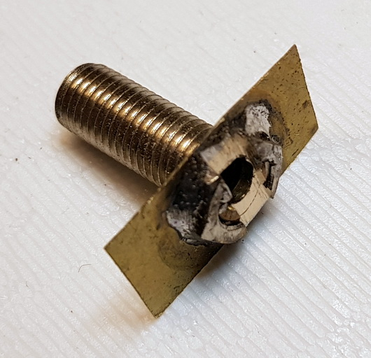 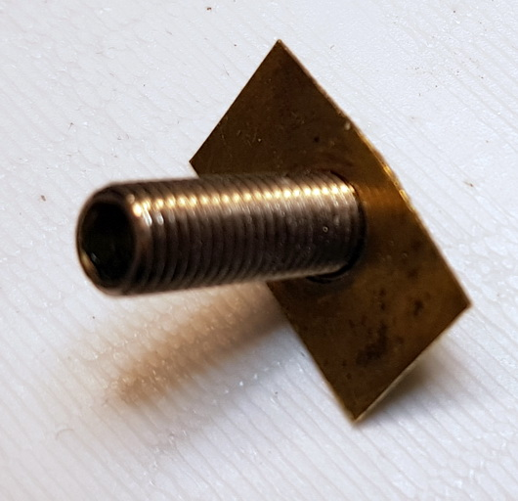 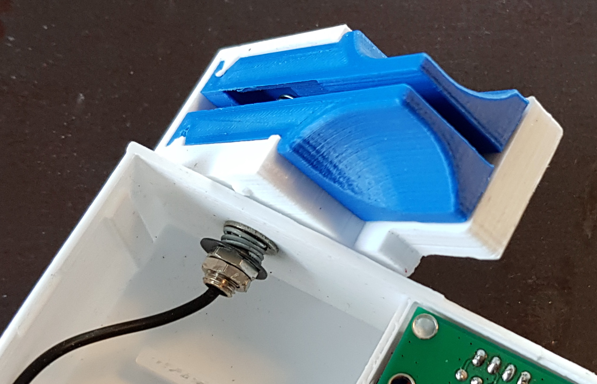

*Figure 2. Left: Axis for paddle rotation. The flanged, threaded tube is fabricated from a banana jack and a piece of brass foil. Right: Spring loaded attachment of the paddle base to the QCX enclosure wall, with cable feedthrough. Note one of the bumps on the paddle wall for snapping the rotation movement in place in the operating or parked positions. See text.*

## Mechanical

The most tricky part of the assembly is the paddle and its attachment to the QCX. The paddle design is described in a separate [GitHub repository](https://github.com/tskauli/MorsePaddles) as well as on [Thingiverse](https://www.thingiverse.com/thing:3168497), but here are the particulars for the attachment to the enclosure: Start with the attachment of the paddle base to the cabinet wall. The rotation axis is shown in Figure 2. This part is made from a banana jack with the back end cut off to form a threaded tube. A nut is entered on one end of the tube, and a small piece of brass foil is added to form a flange that fits inside the paddle base. These parts are soldered together as shown. To make more room for wires, file a slot in the nut afterwards. The tube is inserted from inside the paddle frame, with the flange resting against the inner wall. Now comes the tricky part of routing the wires. I used a thin, ultra-flexible cable from a pair of (worn-out) stereo earphones. Insert the cable through the tube into the paddle frame, then down and pull it from the opening at the bottom of the side wall. Then insert the end back into the horizontal hole to have a suitable (5‑10 cm) length of wire coming out from the wiring well at the bottom of the paddle frame. Split the cable into three separate wires in a length of 3‑5 cm. Remove isolation from the ends, which should be tinned, ready for clamping to the paddle contacts. Pull back any excess wire. Make sure that the wiring is flush with the outer wall, and out of the way of the paddle arms. Now insert the cable and tube into the cabinet wall and add a washer, a spring, another washer and a nut. Tighten the nut to get a firm spring loading of the paddle attachment. Then add a second nut as a jam nut to fix things in place. Now assemble the paddle arms according to the instructions for the paddle design.

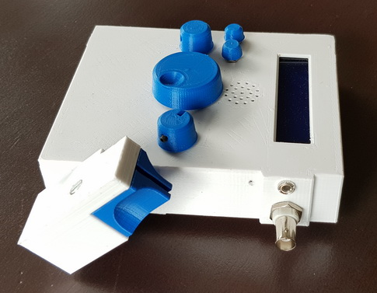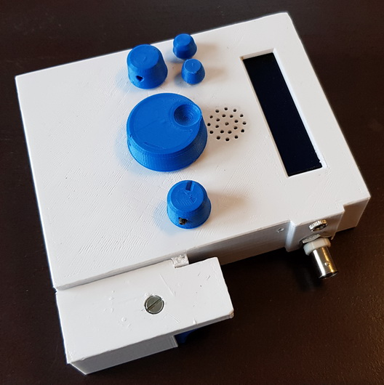

*Figure 3. The finished paddle flips back to a parking position for easier storage.*

The rest of the assembly is shown in the pictures on the following pages. Mount the controls and the earphone jack in their respective holes. The speaker and GPS module fit snugly in frames behind the front panel. Use a little glue, "Blue tack" putty, or tape to keep them in place. (Once all the wiring is in place, they will not have much room to move anyway.) Note that the LEDs on the GPS module are fairly visible through a white wall, but if a darker colour is used then you may want to make some small openings to be able to check the status of the PPS LED. The speaker amplifier module can be mounted with double-sided tape on the back of the volume pot. The remaining assembly consists of normal wiring of the hole-mounted controls to the QCX board. Wires to the battery and paddles can be routed through the slitted holes in the battery compartment wall. The design incorporates a small stopper in the battery compartment to keep the battery in place, which may need to be moved or removed depending on the choice of battery. Note that it is perfectly possible to change the size of the battery compartment by modifying parameters for battery size in the OpenScad code.

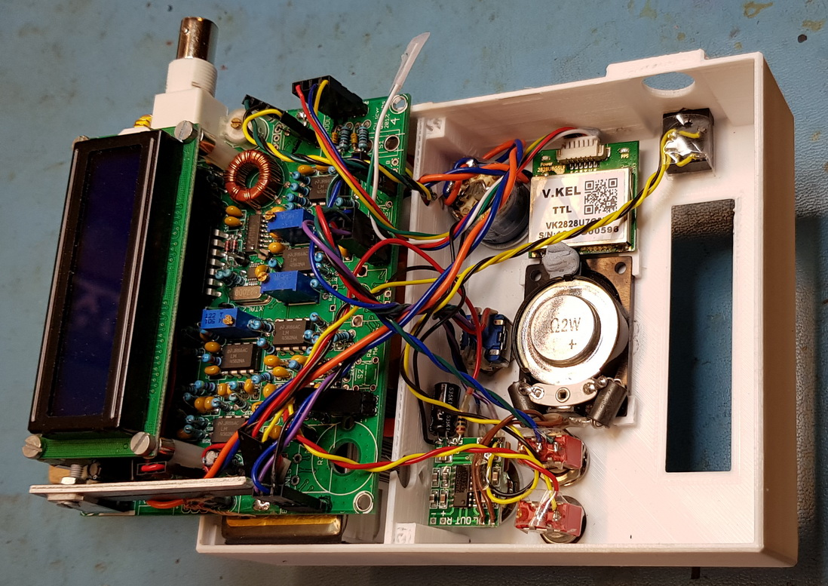

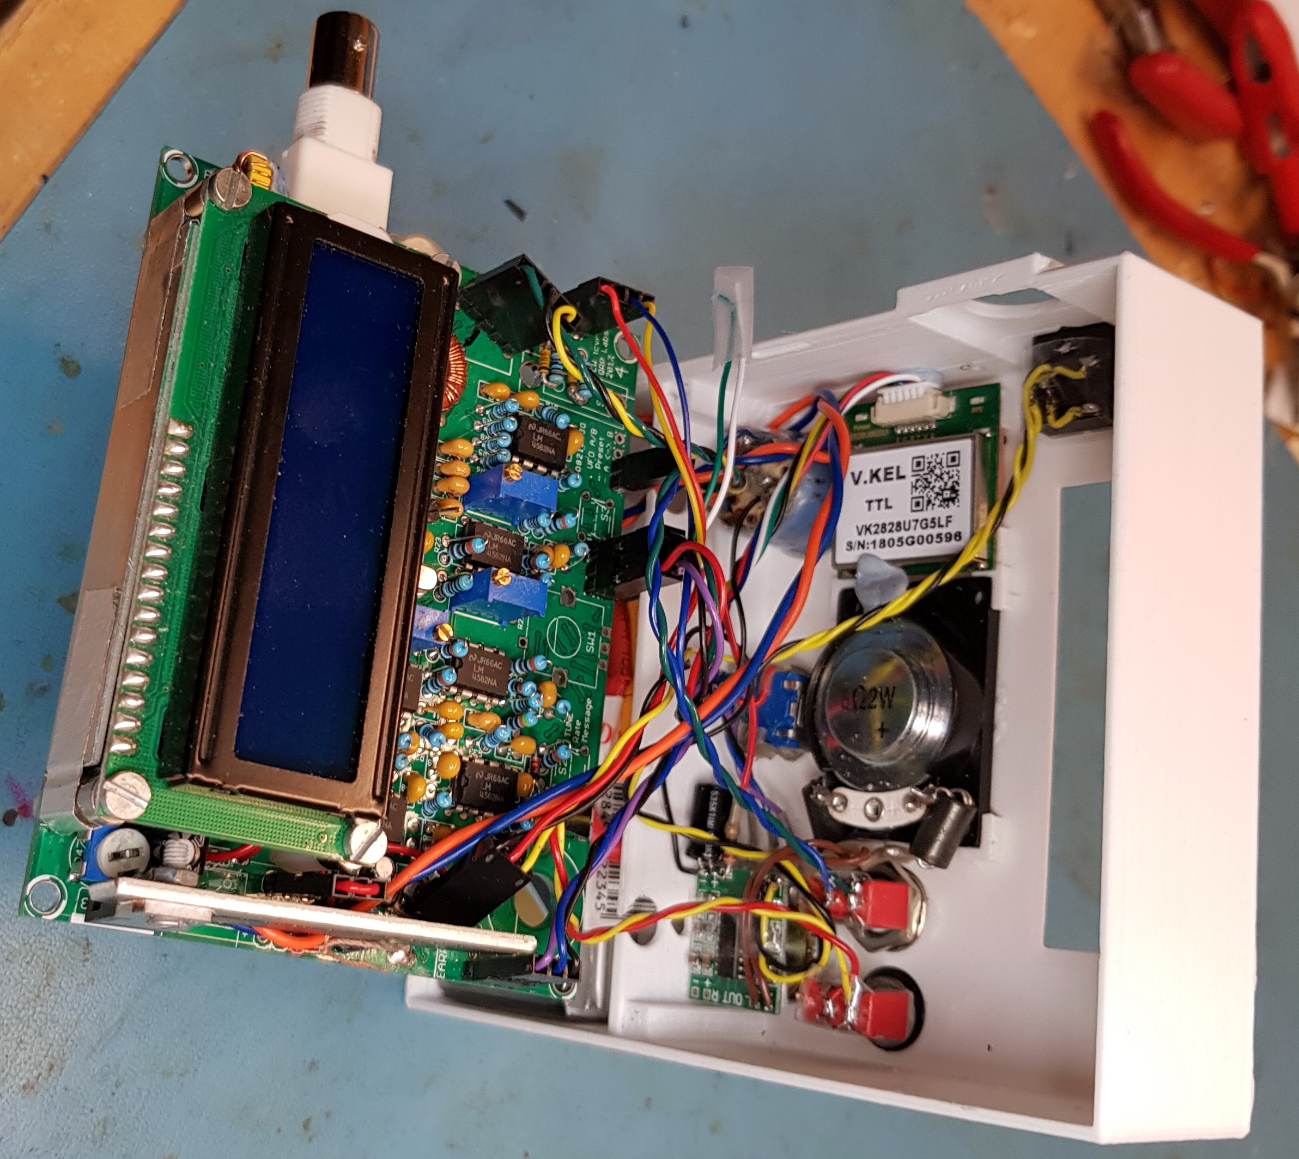

*Interior view after wiring. Note the extra 5mm spacers under the display PCB. Also note the heat spreaders on PA transistors and 5V regulator. Connectors are used on most interfaces for service friendliness, but space for the connectors is tight. Note the small speaker amplifier in the lower left of the front panel. (There is a wiring error in these images: The unconnected white wire from the GPS is the PPS signal and had to be swapped with the yellow wire in the GPS connector.)*

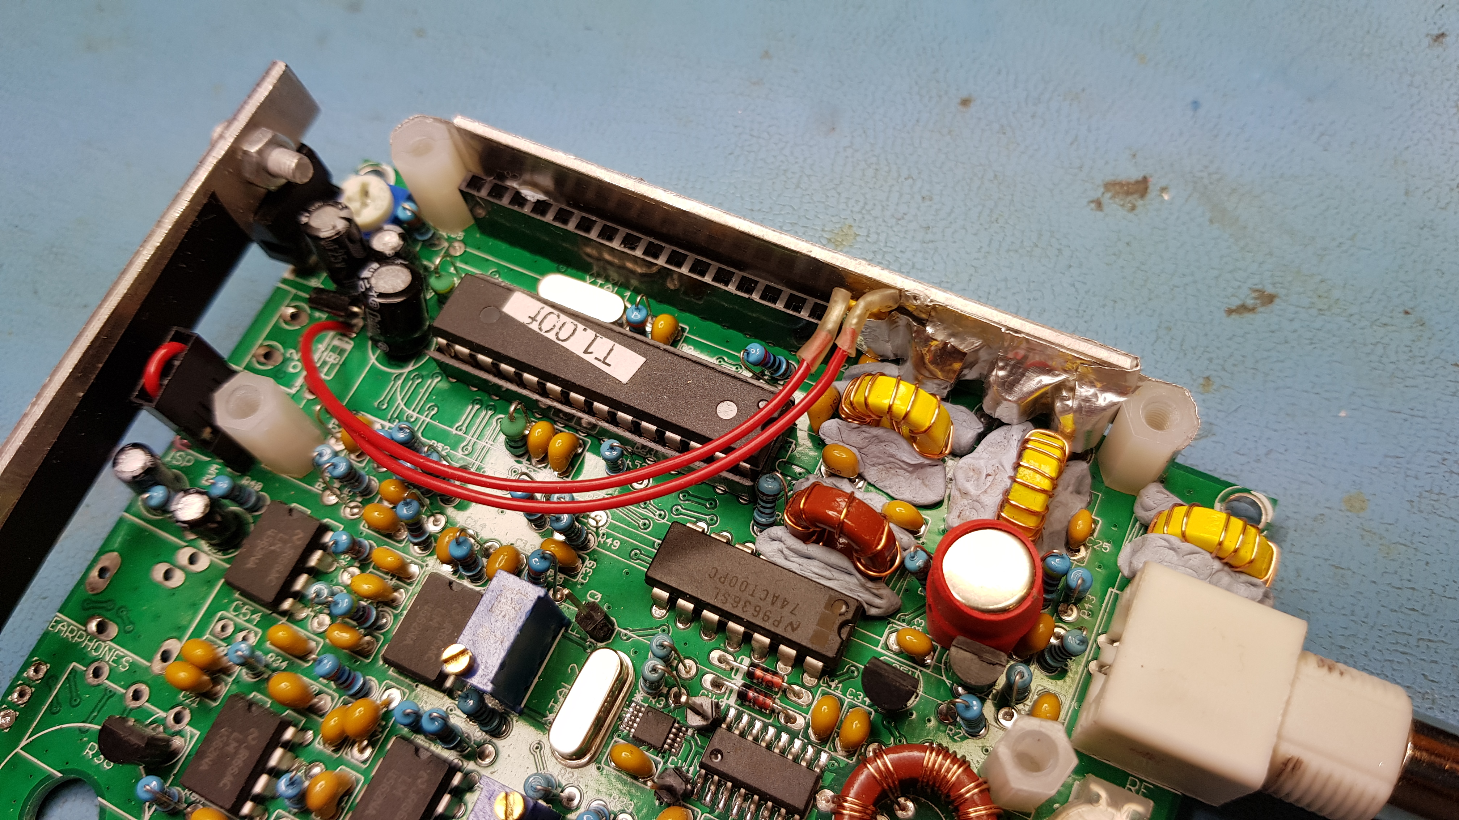

*The polyfuse is attached to the PA heat spreader. This possibly adds some insurance against overheating, since the trip current of the fuse derates with temperature. Toroids are fixed in place with "Blue tack" putty.*

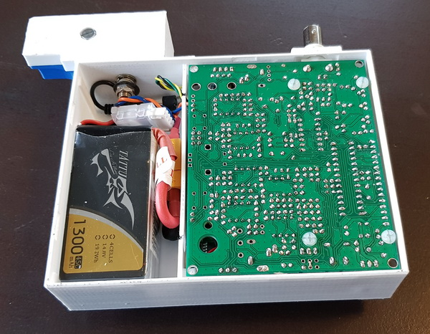

*Inside view showing the battery compartment.*

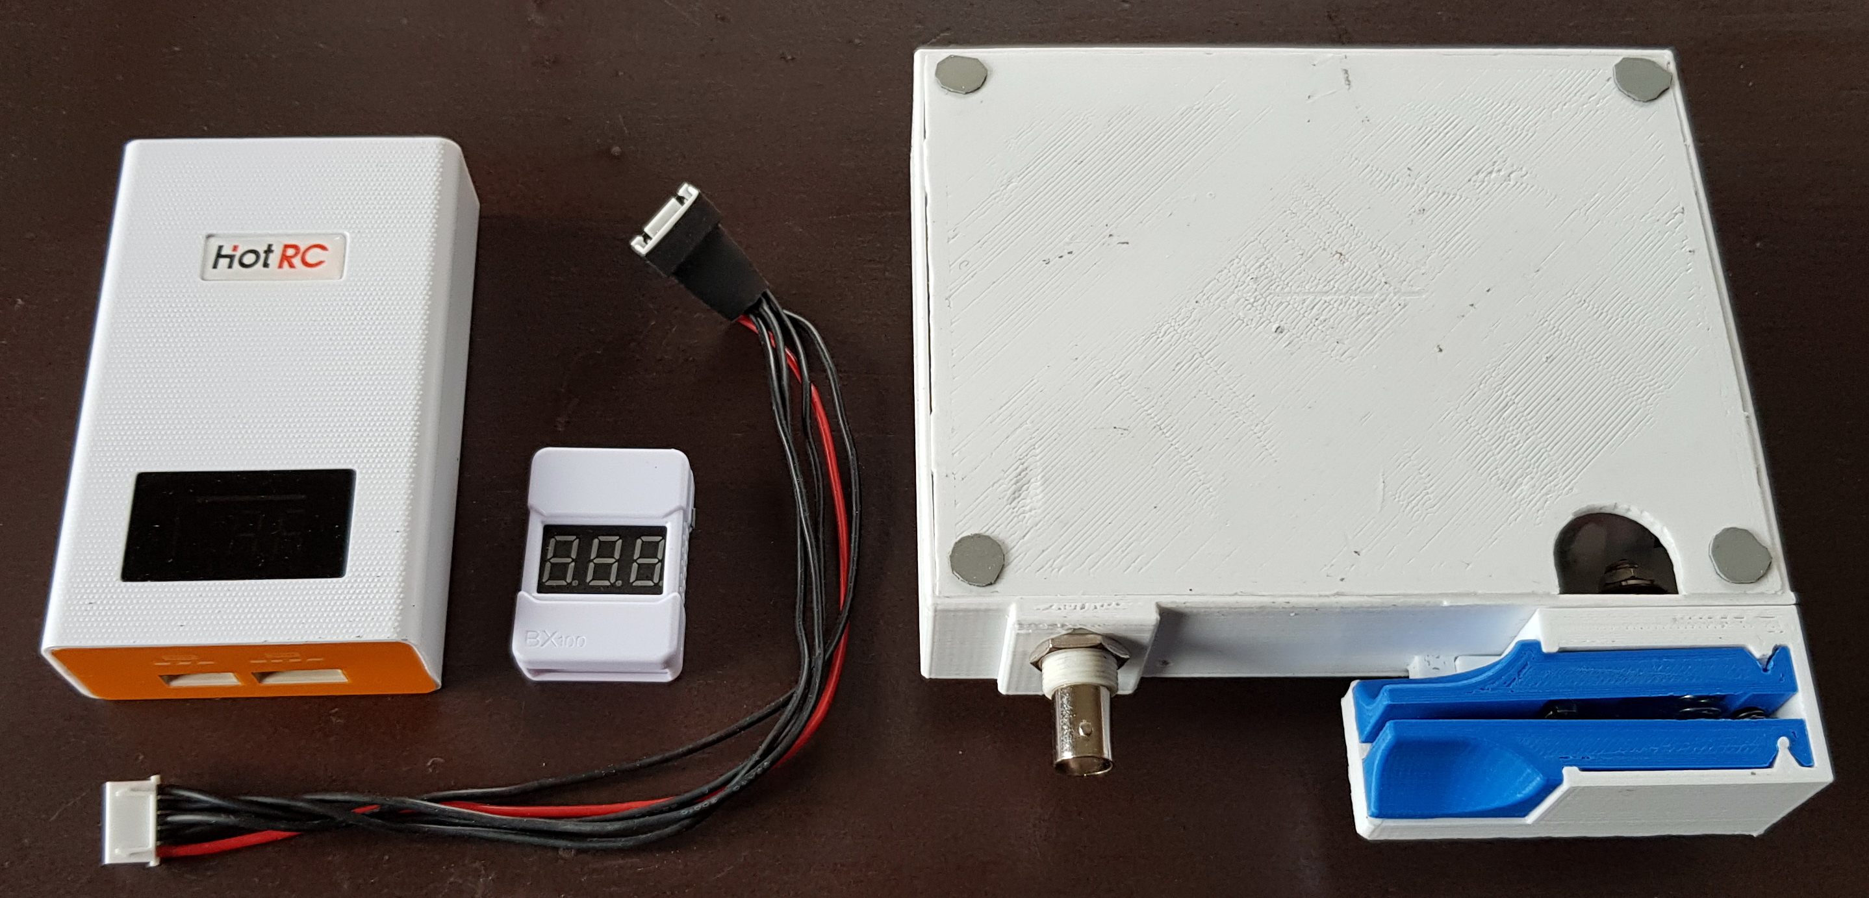

*Bottom view showing the snap-on lid with a finger grip. Rubber pads help keep the unit in place during use. Also shown are some useful accessories: A balancing charger that connects to the balancing port of the battery, with extension cable, and a battery voltage indicator with audible low battery alarm. These items are readily available from various online stores. For long-time WSPR operation, the charger can be left connected while operating.*